Economic Impact of the EU Single Market: Comparative Advantage, Trade Barriers, and Trade Relations
University of the People
ECON 1580-01 Applied Economics: Theory and Practice
Instructor: Dr Ramanpreet Kaur
December 30, 2025

Economic Impact of the EU Single Market: Comparative Advantage, Trade Barriers, and Trade Relations

Introduction
International trade has been shaped by theories such as comparative advantage, which explain how countries can maximize their welfare by specializing in producing goods with the lowest opportunity cost and then engaging in trade with others. Trade agreements are practical tools that put these theories into action by reducing barriers and promoting economic cooperation between nations. The European Union Single Market is a prominent example, demonstrating both the benefits and challenges of managing economic collaboration among diverse countries. This essay examines the EU Single Market, focusing on its structure, the application of comparative advantage, trade barriers, and its overarching influence on trade relations.

The EU single market and participating countries
The EU Single Market is an extensive trade agreement that brings together 27 European nations to promote the free movement of goods, services, capital, and people (Consilium, 2024). Originating from six founding members, including Belgium, France, Germany, Italy, Luxembourg, and the Netherlands, the market has evolved to cover almost all of Europe. This integration is grounded in a shared regulatory framework, which goes beyond the removal of tariffs to address harmonized standards and legal systems (ResearchFDI, 2024). The Single Market’s scope now includes policy areas such as environmental protection and health, reflecting the EU’s transformation into a multifaceted union. This breadth has fostered stability, growth, and deeper regional ties over several decades (Salm & André, 2017). The EU Single Market stands as a leading model of economic cooperation, uniting diverse economies under a collective framework. Figure 1 summarizes the EU timeline from the time it was established to 2020.
Figure 1
European Union timeline
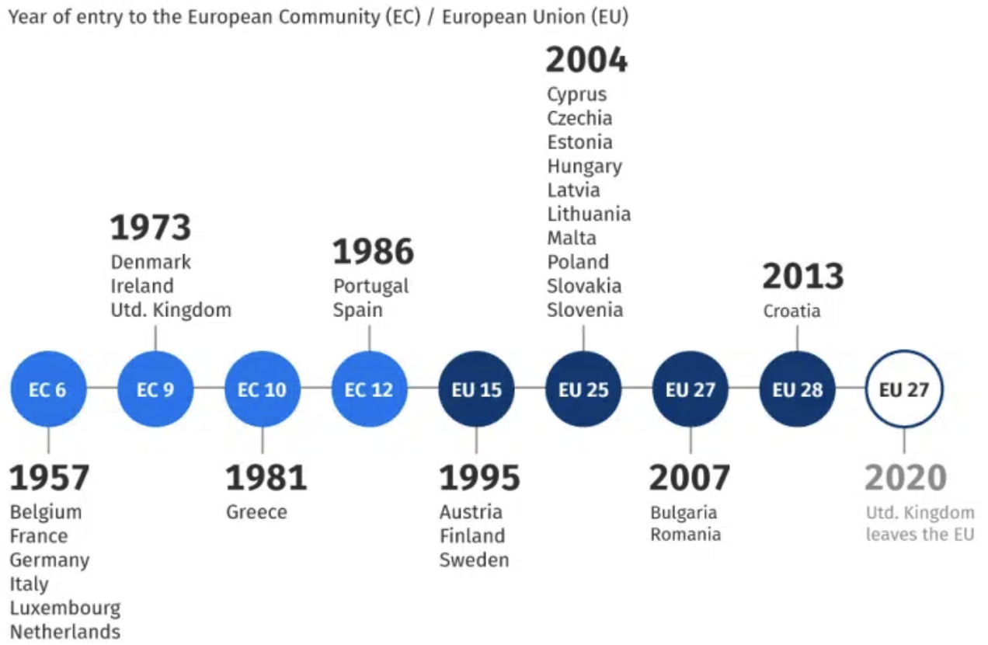

Comparative advantage in the EU Single Market
Comparative advantage lies at the heart of the EU's trade philosophy, allowing member states to specialize in industries where they have a relative efficiency and to engage in mutually beneficial trade (Corporate Finance Institute, 2023). For example, France’s expertise and climate position it as a major wine producer, while Germany leverages its technological prowess in automobile manufacturing (ResearchFDI, 2024). These specializations create opportunities for productive exchange as France exports wine to Germany and imports German vehicles, a clear illustration of gains from trade. Even if one country is generally more efficient, comparative advantage ensures that focusing on relative strengths leads to better economic outcomes for all parties involved (Corporate Finance Institute, 2023). The Single Market amplifies these benefits by removing internal barriers, facilitating smoother transactions, and expanding consumer choice across the region.

Trade barriers in the EU
The EU Single Market was designed to eliminate most tariffs and quota restrictions among its members, yet non-tariff barriers such as subsidies, technical regulations, and border inefficiencies persist (Consilium, 2024). Despite the removal of many barriers, obstacles like differing product standards, labeling requirements, and incomplete infrastructure still complicate cross-border trade (Prouzet, 2025). Recent analyses have shown that these non-tariff barriers can have effects similar to tariffs, potentially increasing costs and limiting access to certain markets (ResearchFDI, 2024). Efforts by EU institutions include harmonizing standards and enforcing competition laws to reduce fragmentation (Consilium, 2024). However, as Prouzet (2025) notes, fully unlocking the Single Market’s potential requires a concerted push to tear down remaining trade barriers and address protectionism. The ongoing challenge is to harmonize interests among member states to ensure that the reduction in barriers results in tangible benefits for businesses and consumers.

Role of the EU single market agreement in shaping trade relations
The Single Market agreement has played a transformative role in shaping intra-European and external trade relations. It has created millions of jobs connected to international trade, increased consumer welfare, and encouraged investment and innovation by expanding market size and competition (Salm & André, 2017). The EU’s trade policies are not limited to economics because they also promote environmental, social, and governance standards (Consilium, 2024). For example, the market’s size allows for greater bargaining power in negotiations with external partners, ensuring European values are considered in trade agreements.
Nevertheless, persistent challenges include imperfect competition and concerns about labor standards, as highlighted by Salm and André (2017). Moreover, Prouzet (2025) emphasizes that protectionist tendencies and regulatory fragmentation threaten the integrity of the Single Market, requiring ongoing vigilance and collaboration to maintain open and fair competition. Therefore, the Single Market’s ability to deliver on its promise hinges on continuous reforms and a shared commitment among member states.

Conclusion
The EU Single Market exemplifies how trade agreements, rooted in the theory of comparative advantage, can enhance prosperity and foster cooperation among a diverse group of nations. By reducing barriers, the Single Market has generated economic growth, increased efficiency through specialization, and provided a platform for shared values and standards. However, persistent non-tariff barriers and protectionist tendencies underscore the importance of continued efforts to unify the market and ensure equitable benefits for all. In conclusion, the EU Single Market remains a compelling model of international economic collaboration, illustrating both the opportunities and complexities of integrated trade arrangements.

References
Consilium. (2024, December 5). EU trade agreements. Council of the EU and the European Council. https://www.consilium.europa.eu/en/policies/trade-agreements/
Corporate Finance Institute. (2023, November 22). Comparative advantage. https://corporatefinanceinstitute.com/resources/economics/comparative-advantage/
Prouzet E. (2025, June 19). Op-ed: Tear down trade barriers to unlock the EU’s single market. The Parliament Magazine. https://www.theparliamentmagazine.eu/news/article/oped-tear-down-trade-barriers-to-unlock-eus-single-market
ResearchFDI. (2024, December 13). What you need to know about the EU single market. https://researchfdi.com/what-you-need-to-know-about-the-eu-single-market/
Salm C., & André C. (2017). Benefits of EU international trade agreements. European Parliamentary Research Service. https://www.europarl.europa.eu/RegData/etudes/BRIE/2017/603269/EPRS_BRI(2017)603269_EN.pdf

